1. 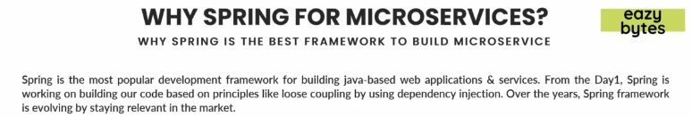
2. You can easily build Rest Service within a minute, and Spring has various projects inside it focusing on each and every problem that we face while building web applications, services or microservices.
3. Some important modules are
   1. Spring Security,
   2. Spring JPA
   3. Spring Cloud
   4. Spring Data
4. So many other modules which are evolving day to day as per market needs.
5. Basic principle on which Spring is built is loose coupling.
6. 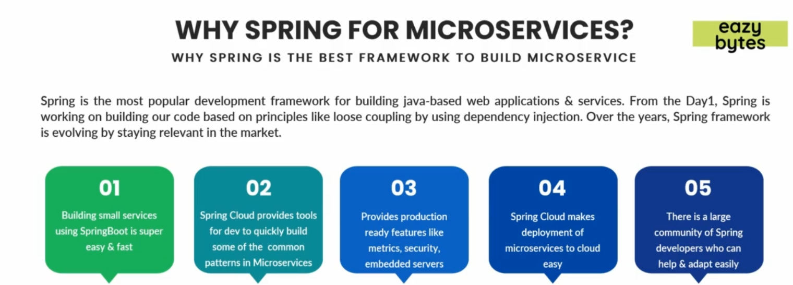
   1. Building small services using SpringBoot is super easy & fast:
      1. With Spring Boot, you can build RESTful Service within a minute without spending much time on configuration & deployment.
   2. Spring Cloud provides tools for dev to quickly build some of the common patterns in microservices:
      1. This project provides
         1. Various tools to quickly build micro-services.
         2. Solutions for various common challenges when building microservices.
         3. Implementations for patterns used in microservices.
   3. Provides production ready features like metrics, security, embedded Server:
      1. You want to check the metrics of your services.
      2. You want to apply security for your services.
      3. Embedded Server for all these services.
   4. Spring Cloud makes deployment of microservices to cloud easy:
      1. Apart from the tools (to build micro-services) provided by Spring Cloud, it has various features that help with deployment of micro-services to various cloud providers like AWS, GCP, Azure very easily.  
         So, this way the DevOps life will be very easy, if you build microservices based on Spring Framework, Spring Boot and Spring Cloud.
   5. There is large community of Spring developers who can help & adapt easily:
      1. There are millions of developers who are already using Spring and who already have a lot knowledge inside the market.   
         So the learning curve is very less.